**Case Study #3 - Foodie-Fi**

Danny Ma · May 18, 2021

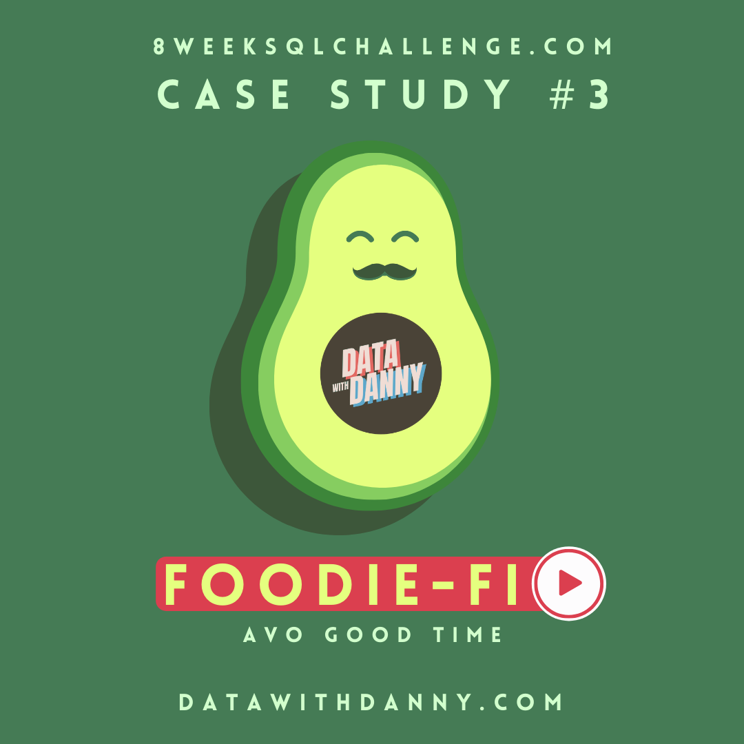

**Introduction**

Subscription based businesses are super popular and Danny realized that there was a large gap in the market - he wanted to create a new streaming service that only had food related content - something like Netflix but with only cooking shows!

Danny finds a few smart friends to launch his new startup Foodie-Fi in 2020 and started selling monthly and annual subscriptions, giving their customers unlimited on-demand access to exclusive food videos from around the world!

Danny created Foodie-Fi with a data driven mindset and wanted to ensure all future investment decisions and new features were decided using data. This case study focuses on using subscription style digital data to answer important business questions.

**Available Data**

Danny has shared the data design for Foodie-Fi and also short descriptions on each of the database tables - our case study focuses on only 2 tables but there will be a challenge to create a new table for the Foodie-Fi team.

All datasets exist within the foodie_fi database schema - be sure to include this reference within your SQL scripts as you start exploring the data and answering the case study questions.

**Entity Relationship Diagram**

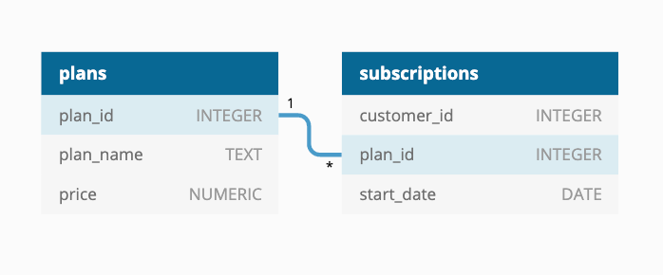

**Table 1: plans**

Customers can choose which plans to join Foodie-Fi when they first sign up.

Basic plan customers have limited access and can only stream their videos and is only available monthly at $9.90

Pro plan customers have no watch time limits and are able to download videos for offline viewing. Pro plans start at $19.90 a month or $199 for an annual subscription.

Customers can sign up to an initial 7-day free trial will automatically continue with the pro monthly subscription plan unless they cancel, downgrade to basic or upgrade to an annual pro plan at any point during the trial.

When customers cancel their Foodie-Fi service - they will have a churn plan record with a null price but their plan will continue until the end of the billing period.

| **plan_id** | **plan_name** | **price** |
| --- | --- | --- |
| 0 | trial | 0 |
| 1 | basic monthly | 9.90 |
| 2 | pro monthly | 19.90 |
| 3 | pro annual | 199 |
| 4 | churn | null |

**Table 2: subscriptions**

Customer subscriptions show the exact date where their specific plan_id starts.

If customers downgrade from a pro plan or cancel their subscription - the higher plan will remain in place until the period is over - the start_date in the subscriptions table will reflect the date that the actual plan changes.

When customers upgrade their account from a basic plan to a pro or annual pro plan - the higher plan will take effect straightaway.

When customers churn - they will keep their access until the end of their current billing period but the start_date will be technically the day they decided to cancel their service.

| **customer_id** | **plan_id** | **start_date** |
| --- | --- | --- |
| 1 | 0 | 2020-08-01 |
| 1 | 1 | 2020-08-08 |
| 2 | 0 | 2020-09-20 |
| 2 | 3 | 2020-09-27 |
| 11 | 0 | 2020-11-19 |
| 11 | 4 | 2020-11-26 |
| 13 | 0 | 2020-12-15 |
| 13 | 1 | 2020-12-22 |
| 13 | 2 | 2021-03-29 |
| 15 | 0 | 2020-03-17 |
| 15 | 2 | 2020-03-24 |
| 15 | 4 | 2020-04-29 |
| 16 | 0 | 2020-05-31 |
| 16 | 1 | 2020-06-07 |
| 16 | 3 | 2020-10-21 |
| 18 | 0 | 2020-07-06 |
| 18 | 2 | 2020-07-13 |
| 19 | 0 | 2020-06-22 |
| 19 | 2 | 2020-06-29 |
| 19 | 3 | 2020-08-29 |

**Interactive SQL Instance**

You can use the embedded DB Fiddle below to easily access these example datasets - this interactive session has everything you need to start solving these questions using SQL.

You can click on the Edit on DB Fiddle link on the top right-hand corner of the embedded session below and it will take you to a fully functional SQL editor where you can write your own queries to analyze the data.

You can feel free to choose any SQL dialect you’d like to use; the existing Fiddle is using PostgreSQL 13 as default.

Serious SQL students will have access to the same relevant schema SQL and example solutions which they can use with their Docker setup from within the course player!

**Case Study Questions**

This case study is split into an initial data understanding question before diving straight into data analysis questions before finishing with 1 single extension challenge.

**A. Customer Journey**

Based off the 8 sample customers provided in the sample from the subscriptions table, write a brief description about each customer’s onboarding journey.

Try to keep it as short as possible - you may also want to run some sort of join to make your explanations a bit easier!  
ANS: -  
SELECT

s.customer_id, p.plan_id, p.plan_name, s.start_date

FROM

subscriptions s

JOIN

plans p USING (plan_id)

ORDER BY customer_id;

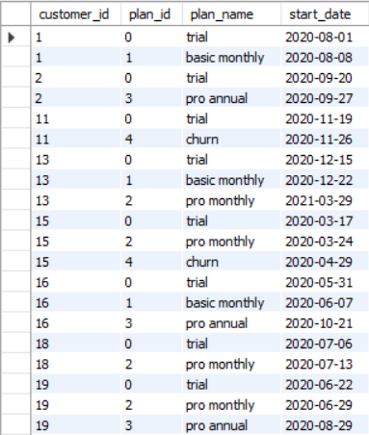

EXPLANATION ->

* Customer with ID 1 started with a trial subscription and continued with a basic monthly subscription in 7 days after sign-up
* Customer with ID 2 started with a trial subscription and continued with a pro annual subscription in 7 days after sign-up
* Customer with ID 11 started with a trial subscription and has churned in 7 days after sign-up
* Customer with ID 13 started with a trial subscription, then purchased a basic monthly subscription in 7 days after sign-up and in 7 days after that has upgraded to a pro monthly subscription
* Customer with ID 15 started with a trial subscription, purchased a basic monthly subscription in 7 days after sign-up and has churned in a month
* Customer with ID 16 started with a trial subscription, purchased a basic monthly subscription in 7 days after sign-up and in 4 months after that has upgraded to a pro annual subscription
* Customer with ID 18 started with a trial subscription and continued with a pro monthly subscription in 7 days after sign-up
* Customer with ID 19 started with a trial subscription, continued with a pro monthly subscription in 7 days after sign-up and has upgraded to pro annual subscriptions in 2 months

**B. Data Analysis Questions**

1. How many customers has Foodie-Fi ever had?

ANS: -

SELECT

COUNT (DISTINCT customer_id) AS num_customer_id

FROM

subscriptions;

Result ->



Foodie-Fi has 8 customers.

1. What is the monthly distribution of trial plan start_date values for our dataset - use the start of the month as the group by value?

ANS: -

SELECT

MONTH (start_date) AS months,

COUNT (customer_id) AS num_customers

FROM

subscriptions

GROUP BY months

ORDER BY months;

Result ->

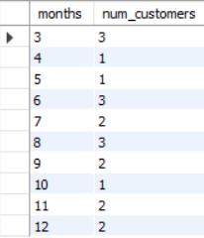

1. What plan start_date values occur after the year 2020 for our dataset? Show the breakdown by count of events for each plan_name  
   ANS: -

SELECT

p.plan_name, p.plan_id, COUNT(*) AS cnt_event

FROM

subscriptions s

JOIN

plans p USING (plan_id)

WHERE

s.start_date > '2020-12-31'

GROUP BY p.plan_id , p.plan_name

ORDER BY p.plan_id;

Result ->



1. What is the customer count and percentage of customers who have churned rounded to 1 decimal place?

ANS: -

SELECT

COUNT(*) AS cust_churn,

ROUND(COUNT(*) * 100 / (SELECT

COUNT (DISTINCT customer_id)

FROM

subscriptions),

1) AS perc_churn

FROM

subscriptions

WHERE

plan_id = 4;

Result ->



It is 25.0% of customers who have churned the plans.

1. How many customers have churned straight after their initial free trial - what percentage is this rounded to the nearest whole number?

ANS: -

WITH cte_churn AS (

SELECT

*, LAG (plan_id,1) OVER (PARTITION BY customer_id ORDER BY plan_id) AS prev_plan

FROM subscriptions)

SELECT

COUNT (prev_plan) AS cnt_churn,

ROUND(COUNT(*) * 100 / (SELECT COUNT (DISTINCT customer_id)

FROM subscriptions),0) AS perc_churn

FROM cte_churn

WHERE plan_id = 4 AND prev_plan = 0;

Result ->



There are 1 customer who have churned straight after their initial free trial, which 13% of the customer base.

1. What is the number and percentage of customer plans after their initial free trial?

ANS: -

WITH cte_next_plan AS (

SELECT

*, LEAD (plan_id,1) OVER (PARTITION BY customer_id ORDER BY plan_id) AS next_plan

FROM subscriptions)

SELECT

next_plan,

COUNT(*) AS num_cust,

ROUND(COUNT(*) * 100 / (SELECT

COUNT (DISTINCT customer_id)

FROM subscriptions),

1) AS perc_next_plan

FROM cte_next_plan

WHERE next_plan IS NOT NULL AND plan_id = 0

GROUP BY next_plan

ORDER BY next_plan;

Result ->

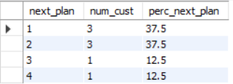

* 37.5% of customers choose basic monthly or next_plan = 1 after their initial trial.
* 37.5% of customers choose pro monthly or next_plan = 2 after their initial trial.
* 12.5% of customers choose pro annual or next_plan = 3 after their initial trial.
* 12.5% of customers choose churn or next_plan = 4 after their initial trial.

1. What is the customer count and percentage breakdown of all 5 plan_name values at 2020-12-31?

ANS: -

WITH cte_next_date AS (

SELECT

*, LEAD (start_date,1) OVER (PARTITION BY customer_id ORDER BY start_date) AS next_date

FROM subscriptions

WHERE start_date <= '2020-12-31'),

plans_breakdown AS (

SELECT

plan_id, COUNT (DISTINCT customer_id) AS num_customer

FROM cte_next_date

WHERE (next_date IS NOT NULL AND (start_date < '2020-12-31' AND next_date > '2020-12-31'))

OR (next_date IS NULL AND start_date < '2020-12-31')

GROUP BY plan_id)

SELECT

plan_id,

num_customer,

ROUND (num_customer * 100 / (SELECT COUNT (DISTINCT customer_id)

FROM subscriptions),1) AS perc_customer

FROM plans_breakdown

GROUP BY plan_id , num_customer

ORDER BY plan_id;

Result ->

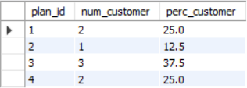

1. How many customers have upgraded to an annual plan in 2020?

ANS: -

SELECT

COUNT (customer_id) AS num_customer

FROM subscriptions

WHERE plan_id = 3

AND start_date <= '2020-12-31';

Result ->



There are 3 customers who have upgraded to annual in 2020.

1. How many days on average does it take for a customer to an annual plan from the day they join Foodie-Fi?

ANS: -

WITH annual_plan AS (

SELECT

customer_id, start_date AS annual_date

FROM subscriptions

WHERE plan_id = 3),

trial_plan AS (

SELECT

customer_id, start_date AS trial_date

FROM subscriptions

WHERE plan_id = 0)

SELECT

ROUND (AVG (DATEDIFF (annual_date, trial_date)),0) AS avg_upgrade

FROM annual_plan ap

JOIN trial_plan tp ON ap.customer_id = tp.customer_id;

Result ->



On average, it takes 73 days for a customer take an annual plan from the day they joined Foodie-Fi.

1. Can you further breakdown this average value into 30 day periods (i.e. 0-30 days, 31-60 days etc.)

ANS: -

WITH annual_plan AS (

SELECT

customer_id, start_date AS annual_date

FROM subscriptions

WHERE plan_id = 3),

trial_plan AS (

SELECT

customer_id, start_date AS trial_date

FROM subscriptions

WHERE plan_id = 0),

day_period AS (

SELECT

DATEDIFF (annual_date, trial_date) AS diff

FROM trial_plan tp

LEFT JOIN annual_plan ap ON tp.customer_id = ap.customer_id

WHERE annual_date is not null),

bins AS (

SELECT

*, FLOOR (diff/30) AS bins

FROM day_period)

SELECT

CONCAT ((bins * 30) + 1, ' - ', (bins + 1) * 30, ' days ') AS days,

COUNT (diff) AS total

FROM bins

GROUP BY bins

ORDER BY bins;

Result ->

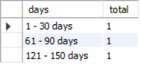

1. How many customers downgraded from a pro monthly to a basic monthly plan in 2020?

ANS: -

WITH next_plan AS (

SELECT

*, LEAD (plan_id, 1) OVER (PARTITION BY customer_id ORDER BY start_date, plan_id) AS plan

FROM subscriptions)

SELECT

COUNT (DISTINCT customer_id) AS num_downgrade

FROM next_plan np

LEFT JOIN plans p ON p.plan_id = np.plan_id

WHERE p.plan_name = 'pro monthly' AND np.plan = 1 AND start_date <= '2020-12-31';

Result ->



There is none of the customers downgraded from a pro monthly to a basic monthly plan in 2020.

**C. Challenge Payment Question**

The Foodie-Fi team wants you to create a new payments table for the year 2020 that includes amounts paid by each customer in the subscriptions table with the following requirements:

* monthly payments always occur on the same day of month as the original start_date of any monthly paid plan
* upgrades from basic to monthly or pro plans are reduced by the current paid amount in that month and start immediately
* upgrades from pro monthly to pro annual are paid at the end of the current billing period and also starts at the end of the month period
* once a customer churn they will no longer make payments

ANS: -  
create table payments as  
with payment as (  
 SELECT  
 s.customer_id as customer_id,  
 s.plan_id as plan_id,  
 p.plan_name as plan_name,  
 CASE  
 WHEN s.plan_id = 1 THEN s.start_date  
 WHEN s.plan_id = 2 THEN s.start_date  
 WHEN s.plan_id = 3 THEN s.start_date  
 WHEN s.plan_id = 4 THEN NULL  
 ELSE '2020-12-31'   
 END AS payment_date,  
 price AS amount  
 FROM  
 subscriptions AS s  
 JOIN plans AS p ON s.plan_id = p.plan_id  
 WHERE  
 s.plan_id != 0  
 AND s.start_date < '2021-01-01'   
 GROUP BY  
 s.customer_id,  
 s.plan_id,  
 p.plan_name,  
 s.start_date,  
 p.price  
 ORDER BY  
 s.customer_id)  
SELECT  
 customer_id,  
 plan_id,  
 plan_name,  
 payment_date,  
 CASE  
 WHEN LAG(plan_id) OVER (  
 PARTITION BY customer_id  
 ORDER BY  
 plan_id  
 ) != plan_id  
 AND (  
 DATEDIFF(payment_date, LAG(payment_date) OVER (  
 PARTITION BY customer_id  
 ORDER BY  
 plan_id  
 ))  
 ) < 30 THEN amount - LAG(amount) OVER (  
 PARTITION BY customer_id  
 ORDER BY  
 plan_id  
 )  
 ELSE amount  
 END AS amount,  
 RANK() OVER(  
 PARTITION BY customer_id  
 ORDER BY payment_date  
 ) AS payment_order   
 from payment  
 order by customer_id,plan_id;

select * from payments;

Result ->  
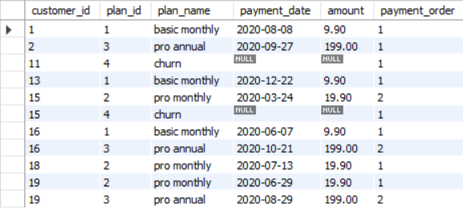

**D. Outside the Box Questions**

The following are open ended questions which might be asked during a technical interview for this case study - there are no right or wrong answers, but answers that make sense from both a technical and a business perspective make an amazing impression!

1. How would you calculate the rate of growth for Foodie-Fi?  
   ANS: -The current months value subtracts the previous months value, then divides to the previous value, multiplying by 100 to get the percentage result. If the value is greater than 0 then the growth is positive, if the value is below or equal to 0 then there is no growth.
2. What key metrics would you recommend Foodie-Fi management to track over time to assess performance of their overall business?  
   ANS: -

* Total number of the customers on a certain date,
* number of active customers (total - churn),
* number of paying customers (total - churn - trial),
* number of new customers on a certain date,
* ratio new to churn customers - to understand if the company grows or losing their customers,
* ratio new customers to paying customers,
* revenue: total revenue, recurring revenue, average revenue per user (ARPU), average revenue per paying user (ARPPU)
* number of active customers by plans - to understand what plan do customers prefer, and to see growth points,
* number of active customers on date after their sign-up (cohort analysis: day 7, day 30, etc).

1. What are some key customer journeys or experiences that you would analyze further to improve customer retention?

ANS: -I think it is important to see what happens on the day 7 when the trial ends - if a user becomes a customer or not. Next, what happens after their purchase - do they stick with it or prefer to upgrade / downgrade it? If a customer decides to cancel their subscription - we can analyze when it happened and how long they used the APP before cancel.

1. If the Foodie-Fi team were to create an exit survey shown to customers who wish to cancel their subscription, what questions would you include in the survey?

ANS: -

* + 1. What is the single biggest reason for you cancelling? - Please select one reason
* I do not understand how to use Foodie-Fi
* Foodie-Fi is too expensive
* I found another product that I like better

Optional follow-up question: What service are you using now?

* I no longer needed Foodie-Fi
* Foodie-Fi service quality is too low
* Foodie-Fi is missing some features that I need

Optional follow-up question: could you please describe the feature you need?

* Other (could you please explain your reason?)

2. Did we meet your expectations?

* Yes
* No

3. What would it take for you to reconsider subscribing to Foodie- Fi? - Optional

4. How can we improve? - Optional, could you please let us know how can we make Foodie-Fi better?

1. What business levers could the Foodie-Fi team use to reduce the customer churn rate? How would you validate the effectiveness of your ideas?

ANS: -

* First need to understand what churn rate we are talking about.
* Churn rate after trial is different from the paying customer churn rate. When a user sign-up, the Foodie-Fi goal is to convert him into customer as quick as possible. Need to show them features of the paid plans and offer a special discount for early subscription for pro plans.
* After the trial ends, it is possible to show limited amount of videos per day for free, and offer another discount.
* Email marketing: if customers subscribed to our email updates we can remind them about the service - not often, when there is something interesting for the user to know. We can remind users about the service via targeted advertisement campaigns too.
* Loyalty program: paying customers can be extra rewarded for their loyalty with bonus points for their future purchases for example. Adding gamification elements to the loyalty program might also work: like goal-setting, countdowns, or virtual rewards.
* Feedback feature - if something goes wrong, and a user or a customer has an option to easily share their opinion or send a bug report - that is fine. Sometimes users are ready to pay but just cannot do it because of some technical problems or something that can be resolved easily.
* If a paying user churns, then we can ask them about the reasons - why they decided to cancel their subscription?
* And also send them some reminders from time to time.

**Conclusion**

This case study should reflect realistic questions we usually focus on for all product related analytics requests in a wide variety of industries, especially in the digital space!

After analyzing everything, I reached the conclusion point that everything is good in Foodie-Fi but some customers are dropping the plan. They're not consistent with it, that's a big problem.

To come out of this they have to add some more attractive plans or they need to give some interesting offers.